ID & Name: 150720062 – Mehmet Ali KAMALAK

Pre-LAB Work
- For the circuits given in Fig. 1, calculate the low (f_{L}) and high (f_{H}) cut-off frequencies.
Assume β=200, Cµ=3pF, Cπ=15pF. (Vcc=15V and Vee=-15V)
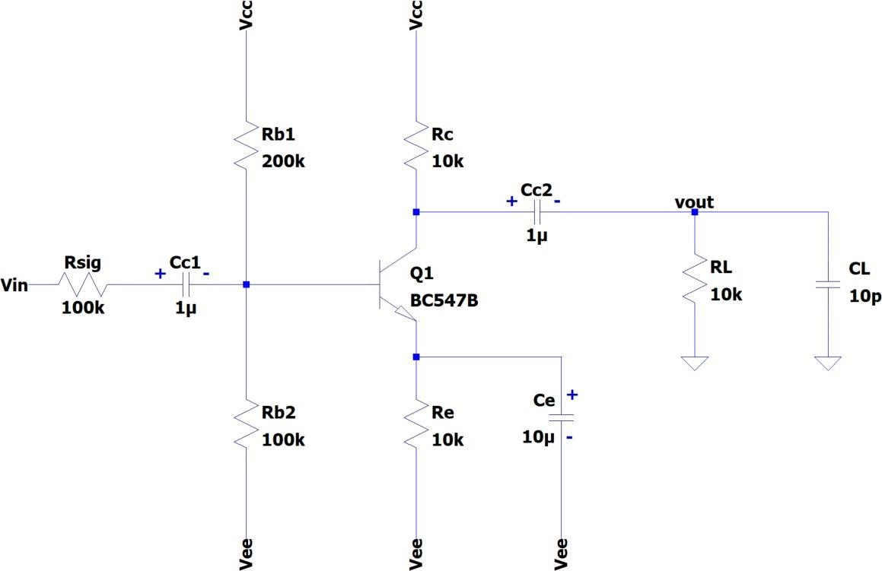

Figure 1
Answer: F low = 105,7 (Hz) F high = 88K (Hz)

- Simulate the circuit in Fig. 1 with SPICE. Let Vcc=15V and Vee=-15V. Conduct an AC analysis using the following spice command and plot the amplitude of the frequency response. Indicate the low (f_{L}) and high (f_{H}) cut-off frequencies.
.ac dec 10 1 10e6 F low = 103(Hz) F high = 72K (Hz)
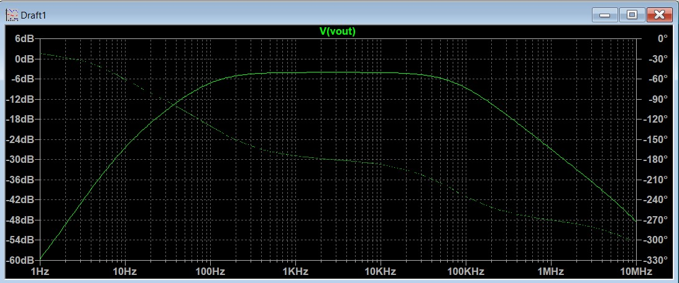

- For the circuits given in Fig. 2, calculate the low (f_{L}) and high (f_{H}) cut-off frequencies.
Assume β=200, Cµ=3pF, Cπ=15pF. (Vcc=15V and Vee=-15V)
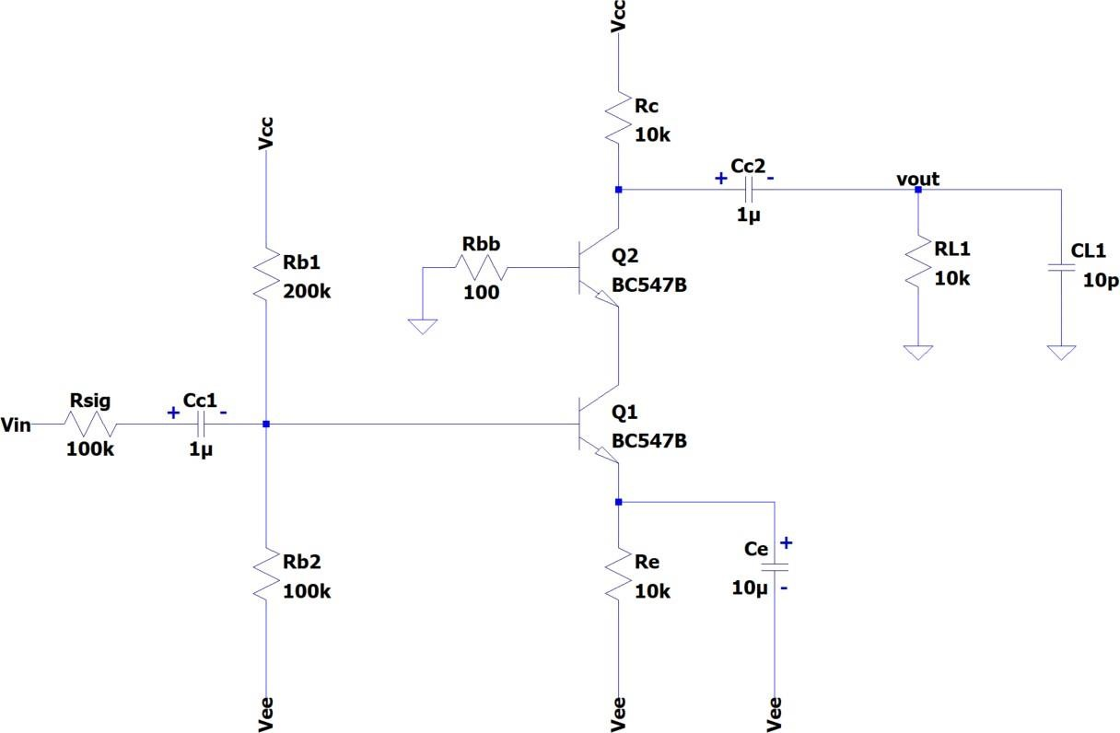

Figure 2

Answer: F low = 100 (Hz)
  - high = 340K (Hz)
- Simulate the circuit in Fig. 2 with SPICE. Let Vcc=15V and Vee=-15V. Conduct an AC analysis and plot the amplitude of the frequency response. Indicate the low (f_{L}) and high
(fH) cut-off frequencies. F low = 101(Hz) F high = 350K (Hz)

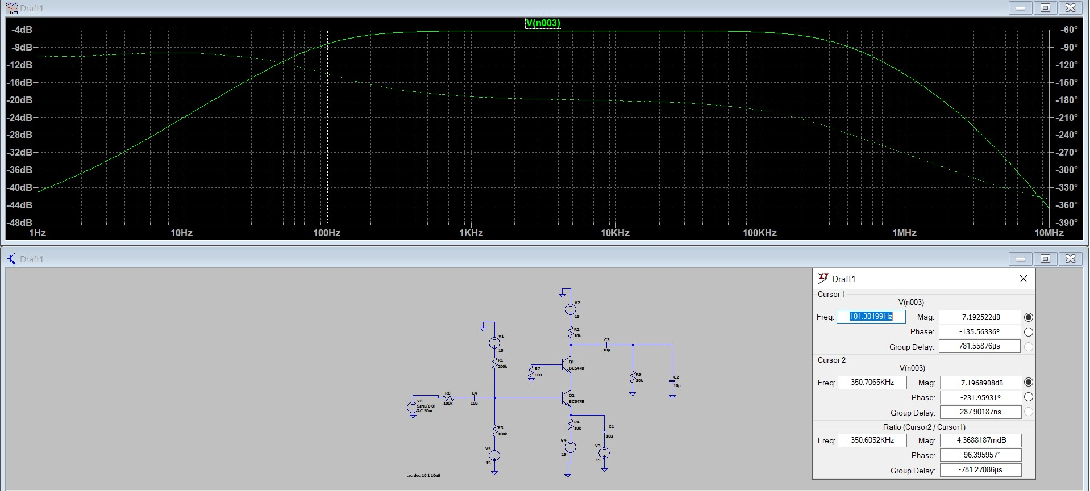

Equipment/Component List
Table 1: Equipment/Component List

Equipment/Component | Model/Value | Count
Breadboard | - | 1
Resistor | 100Ω | 1
Resistor | 10kΩ | 3
Resistor | 100kΩ | 2
Resistor | 200kΩ | 1
Capacitor | 10pF | 1
Capacitor | 1µF | 2
Capacitor | 10µF | 1
BJT (npn) | BC547 | 2
Multi-meter | - | 1
Function Generator | - | 1
Oscilloscope | - | 1
Voltage Source | 15V, -15V | 1
Probes & Cables | - | -

Experiment Procedure
- Adjust Vcc to 15V and Vee to -15V. You will also need the ground connection. Do not connect the supplies.
- Set-up the circuit in Fig. 1. Be very careful while connecting the capacitor. The +/- pins must be connected as shown in the Fig. 1.
- Connect the ground and then Vee and Vcc.
- Apply sine waves of 10Hz, 100Hz, 1kHz, 10kHz, 100kHz, 1MHz, 10MHz with amplitudes of 50mV to Vin.
- Also find the 3-dB cut-off frequencies.
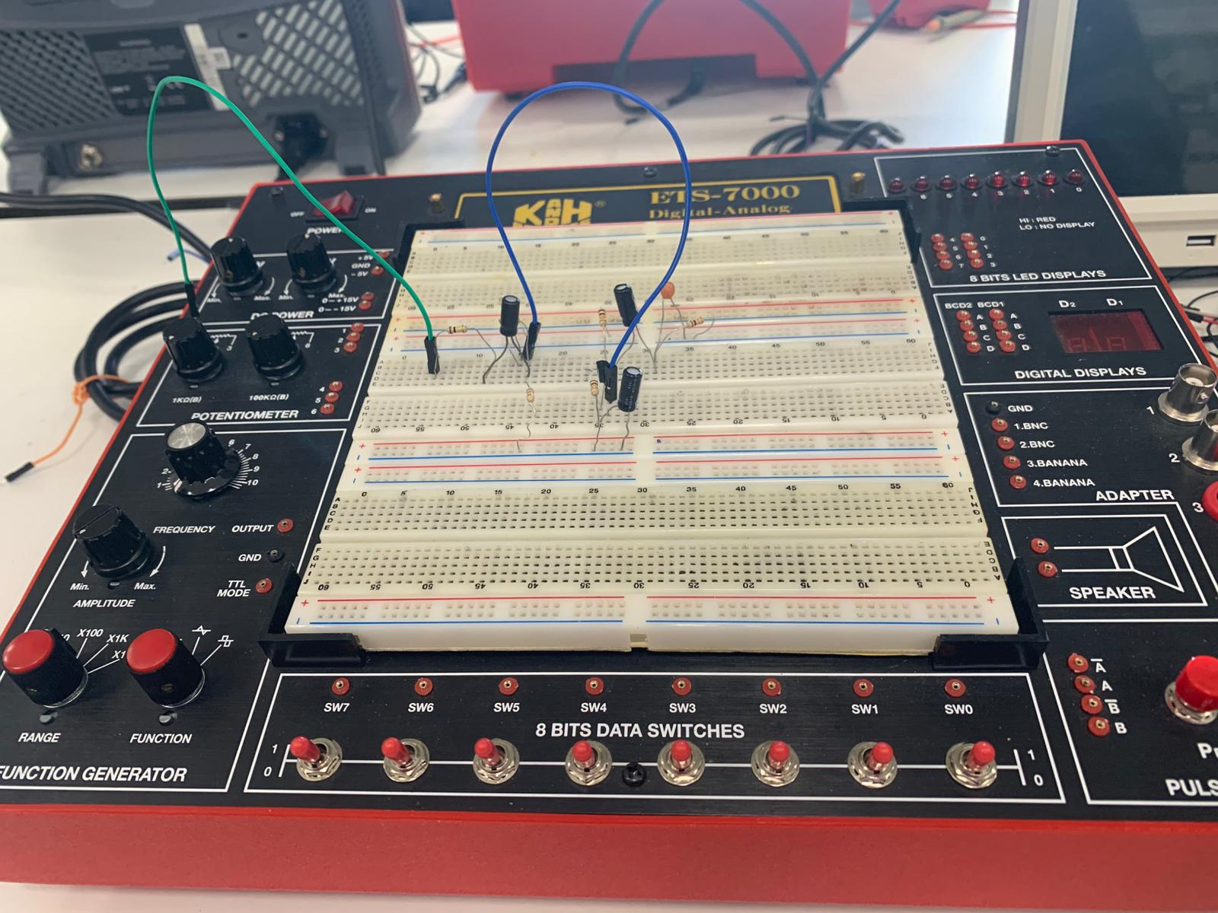
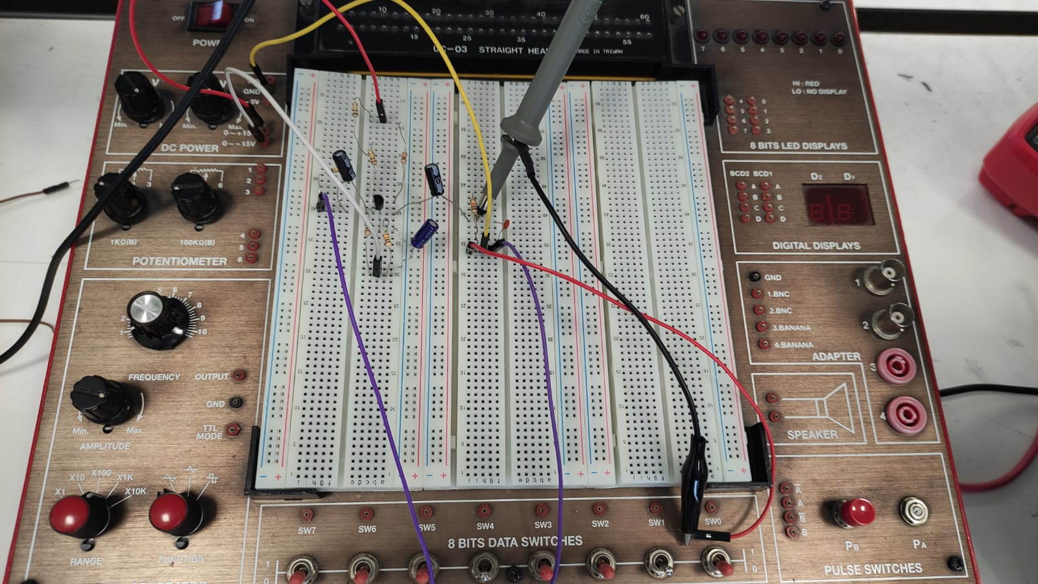
- Plot the gain in dB as a function of the frequency. Indicate the low (f_{L}) and high (f_{H}) cut-off frequencies. F low ~ 300 Hz F high ~10.1K (Hz)
Lab and LTSpice Frequency Response Results

1.Devre
10HZ
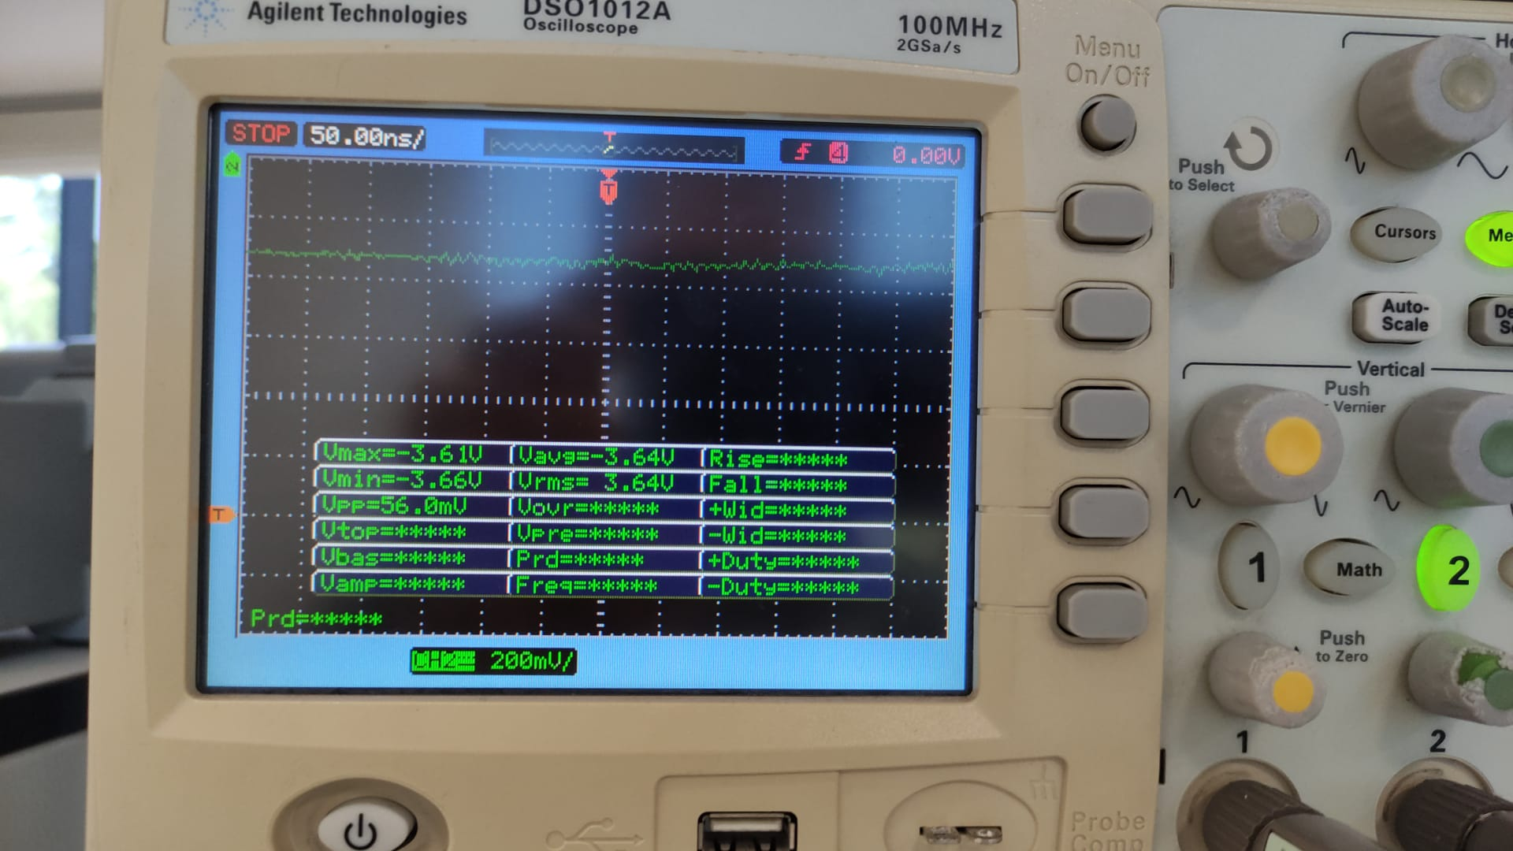
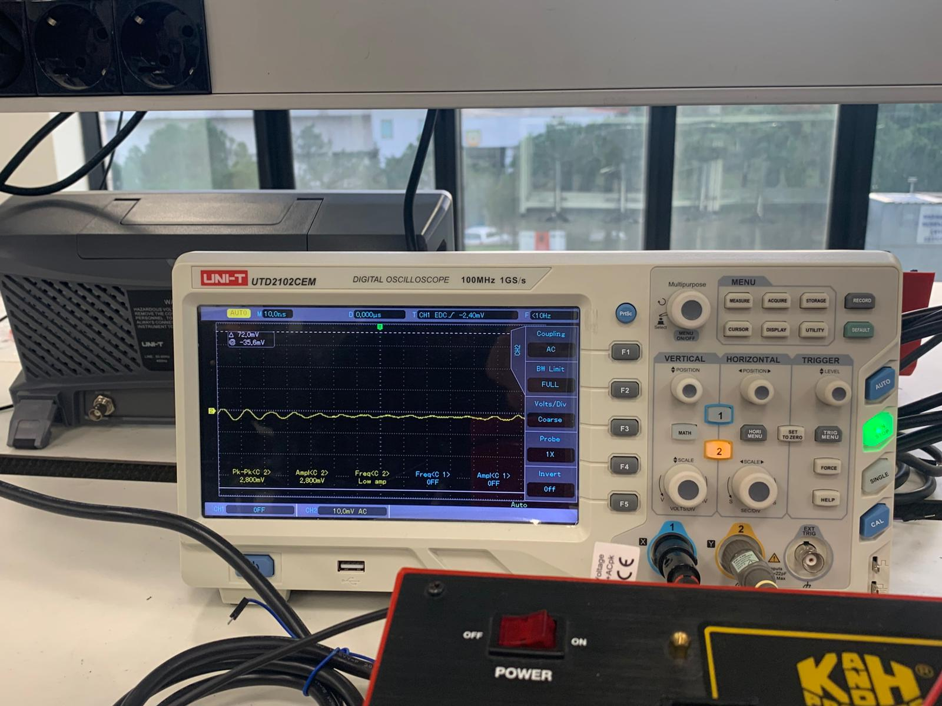

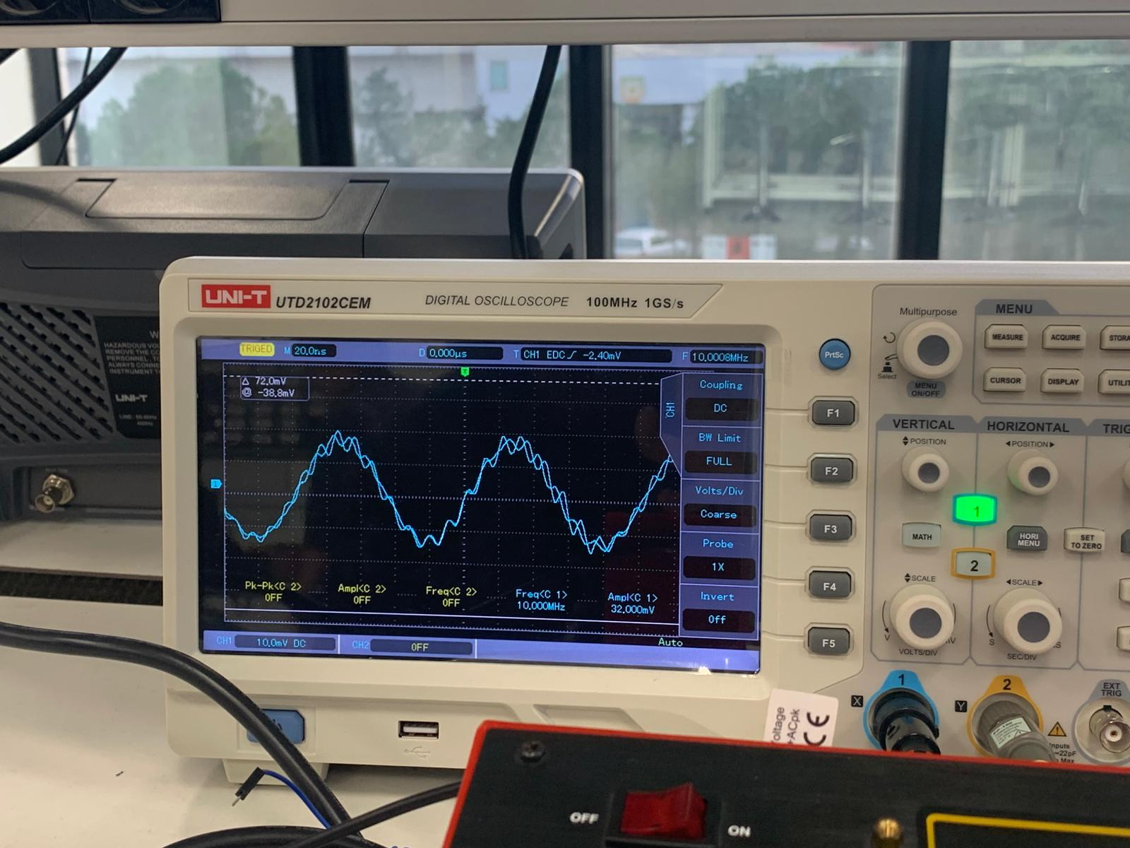
100Hz
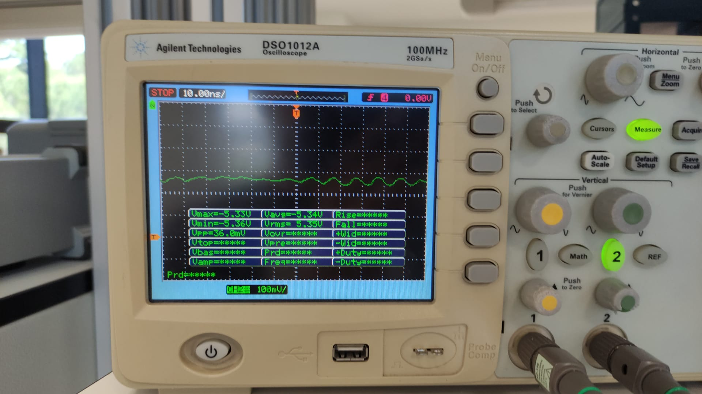

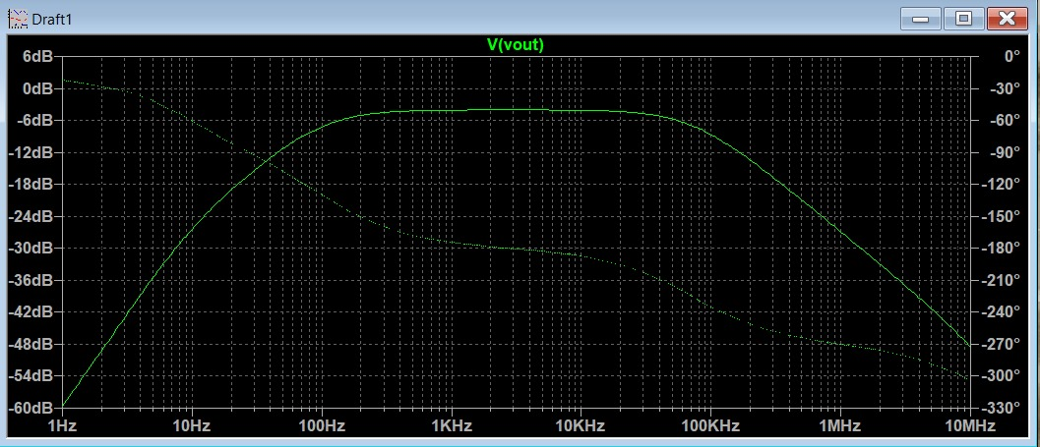

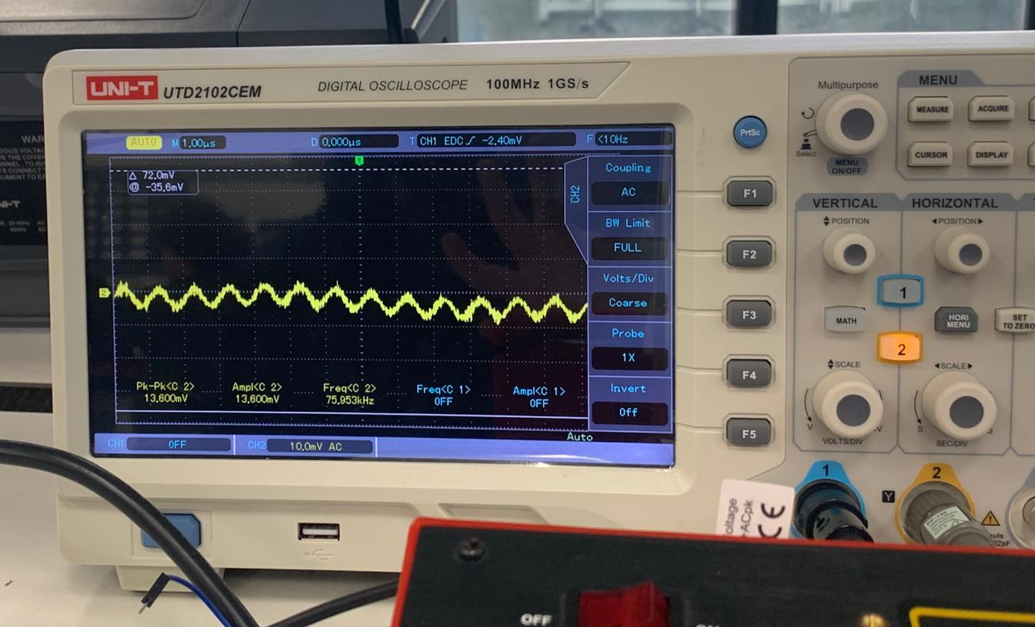
1k Hz
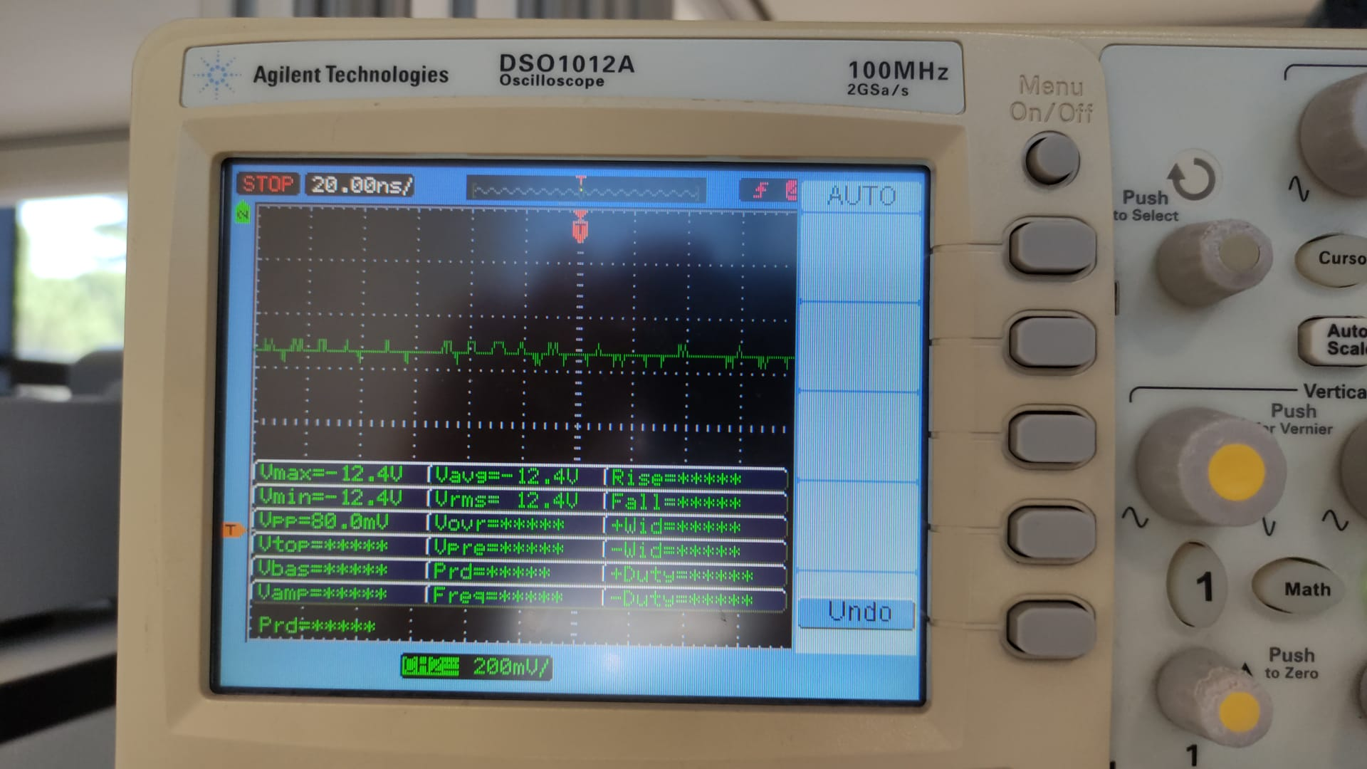

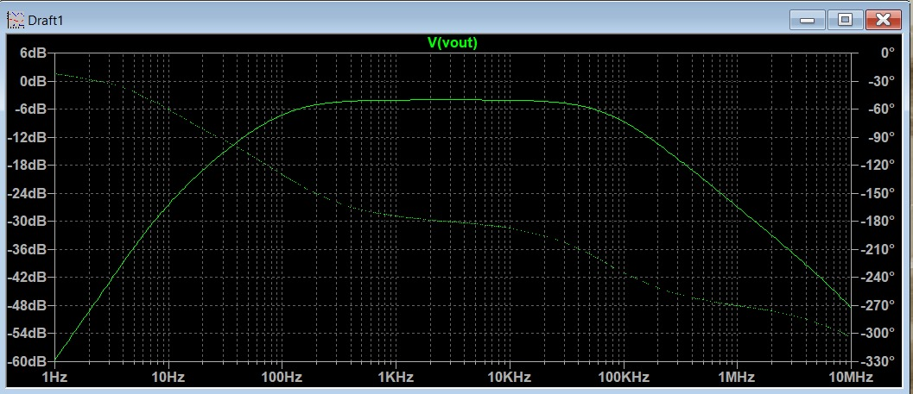

10k Hz
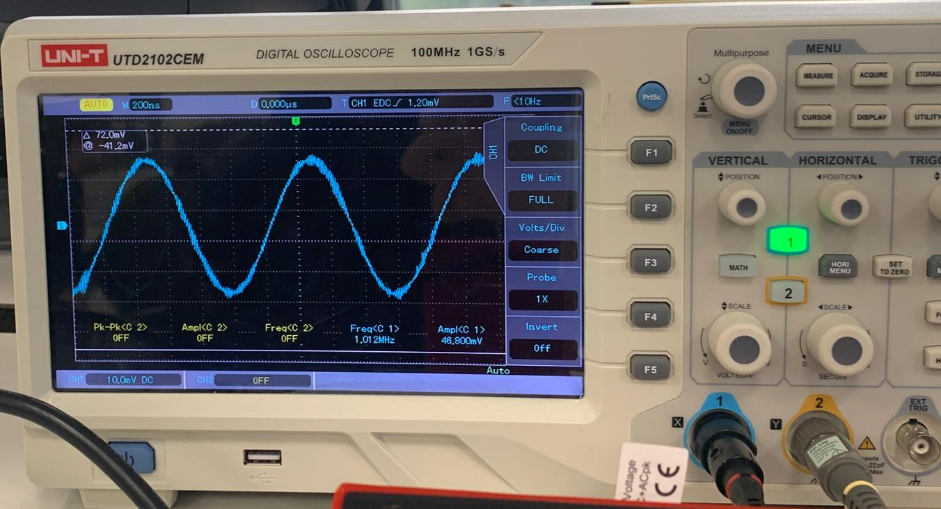
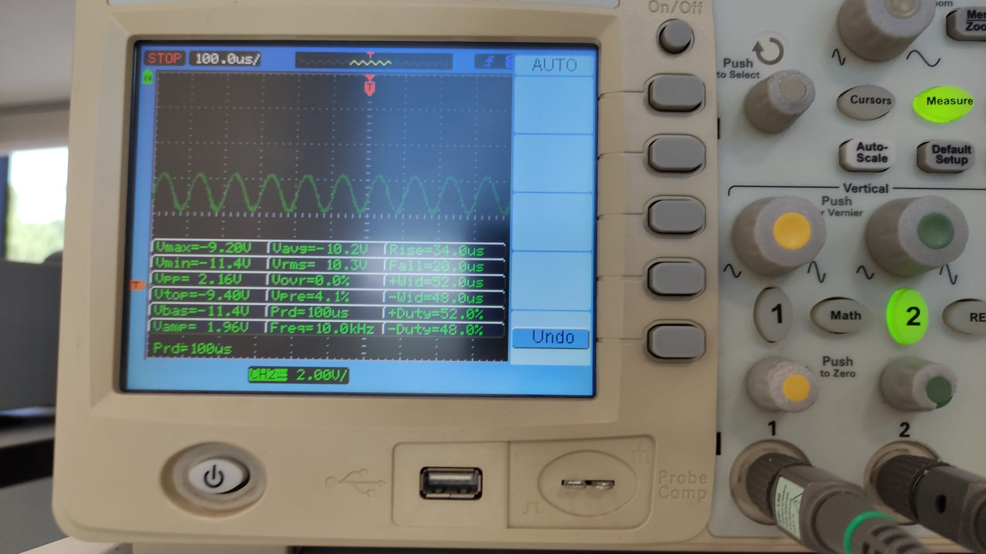

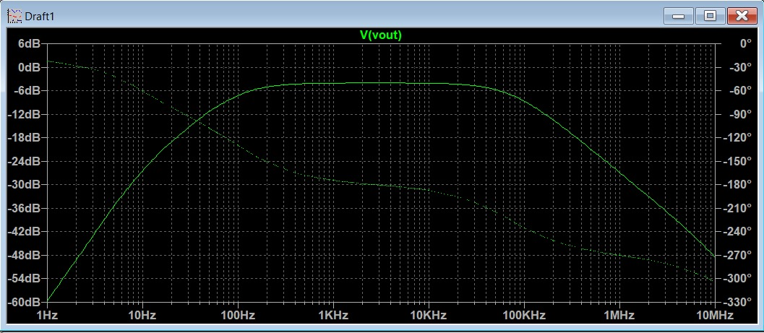

100k Hz
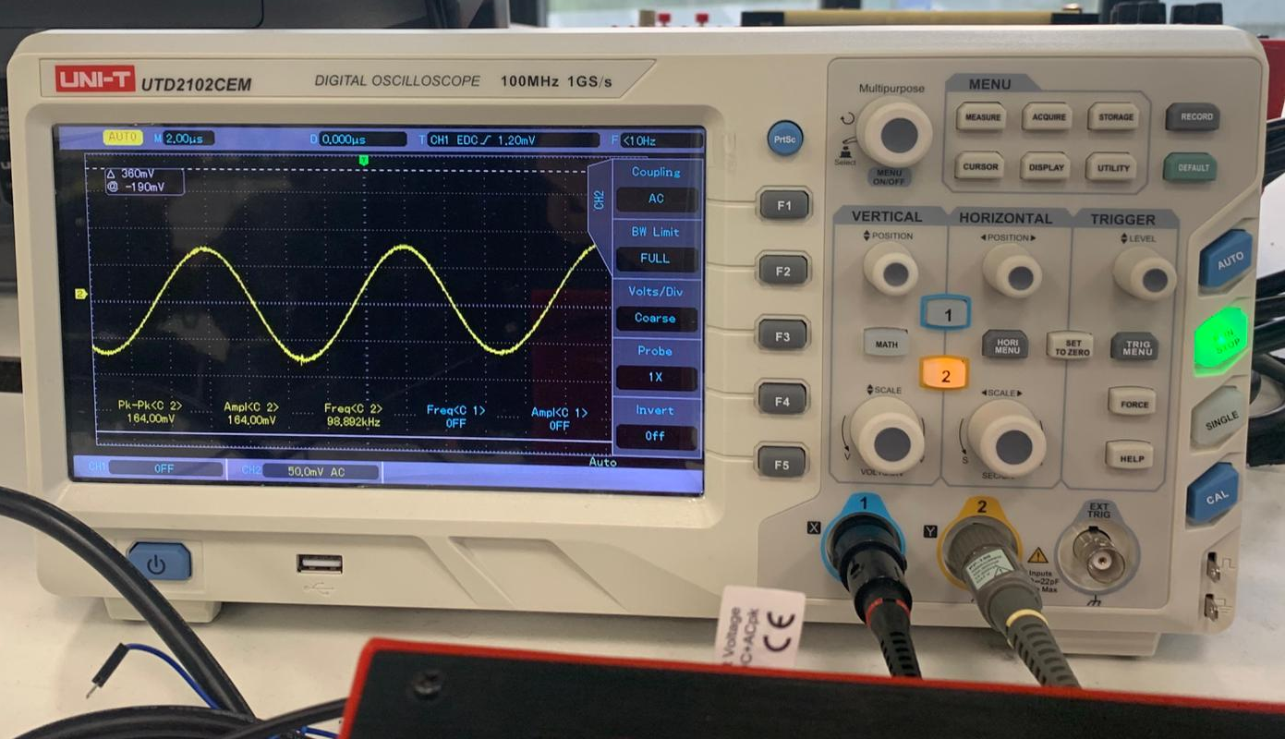
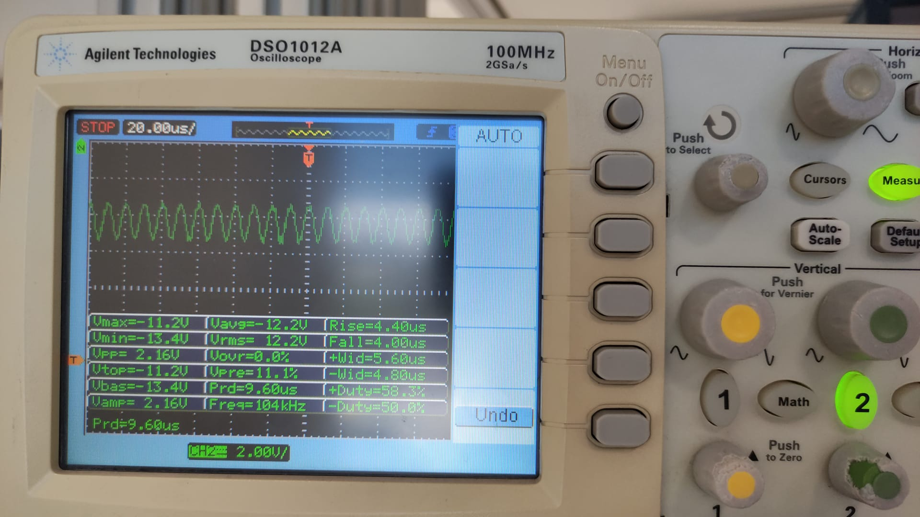

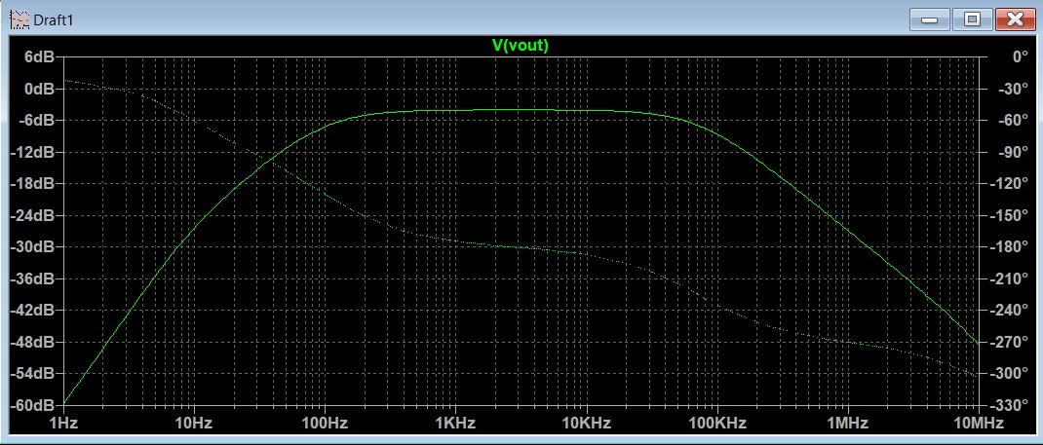

1M Hz
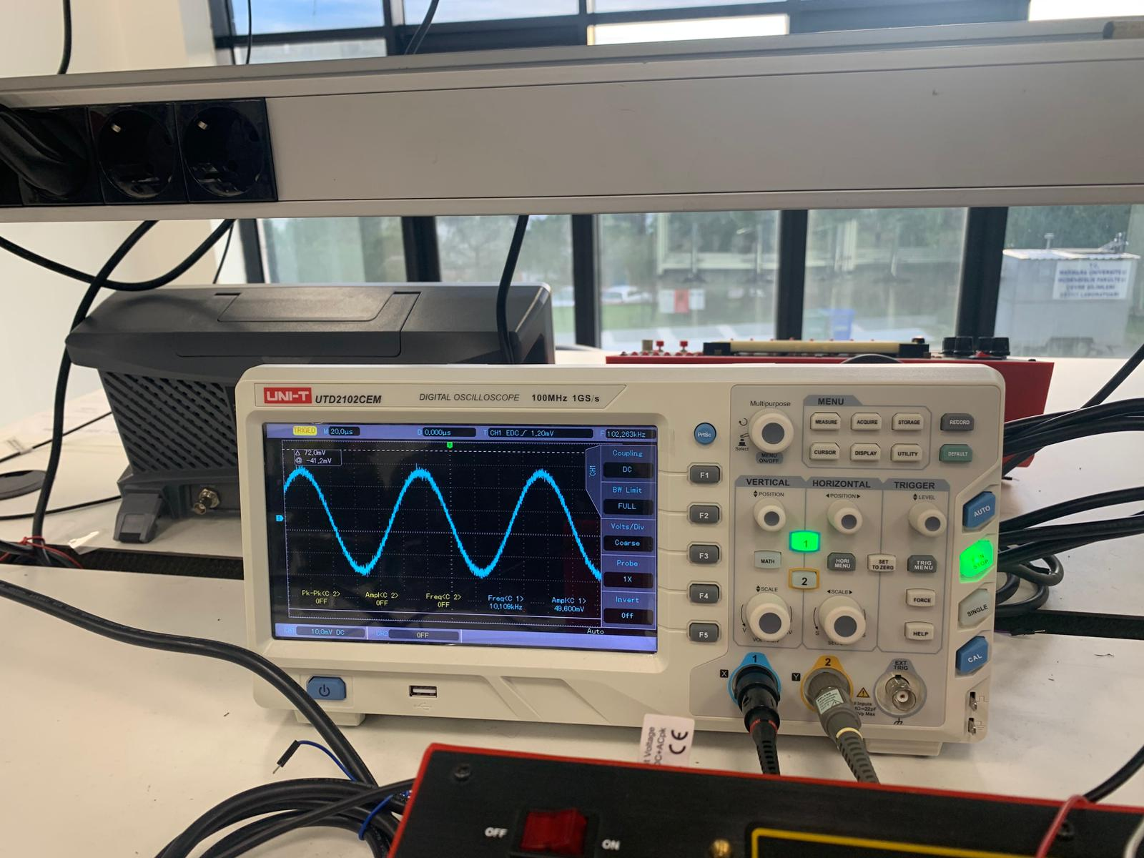
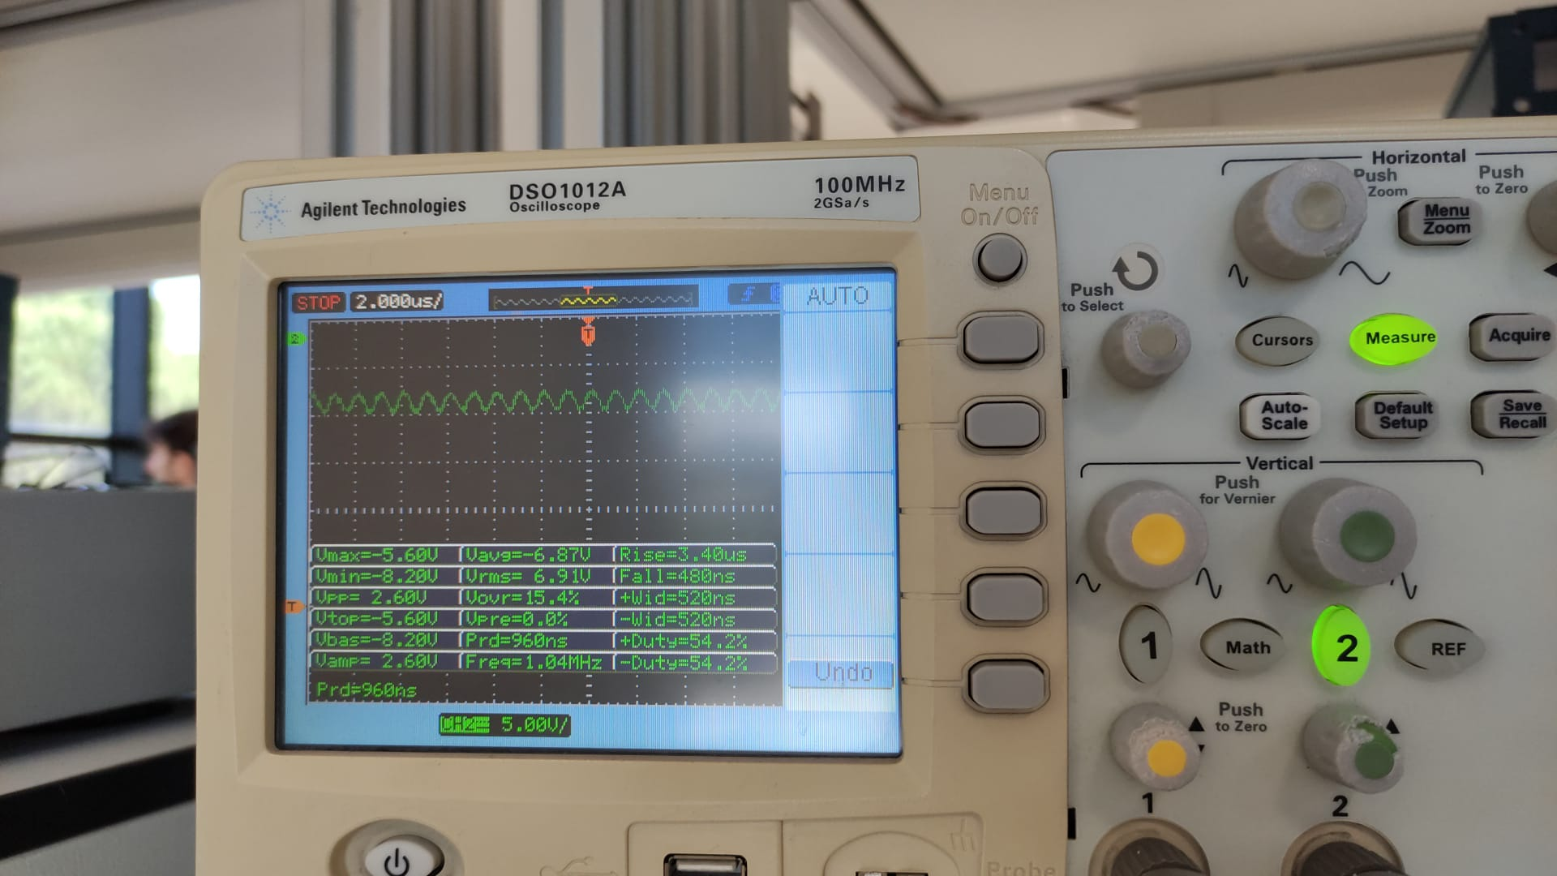

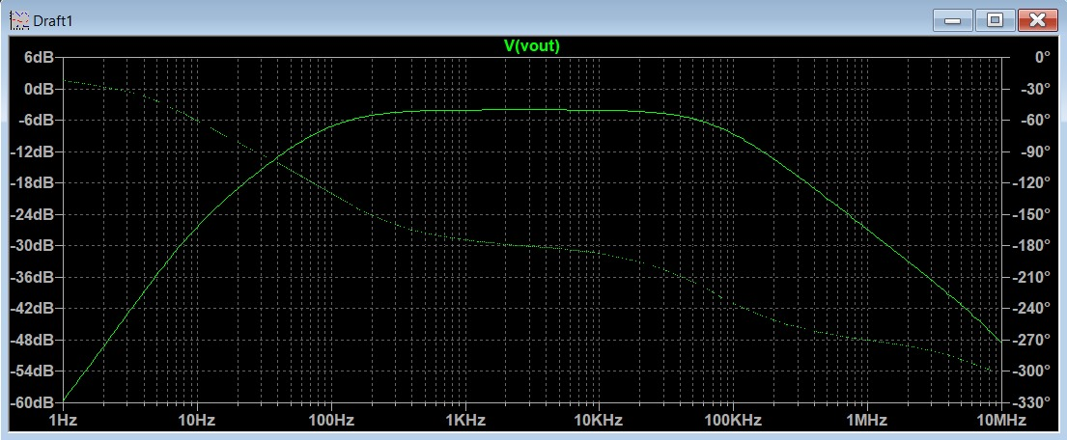

10M Hz
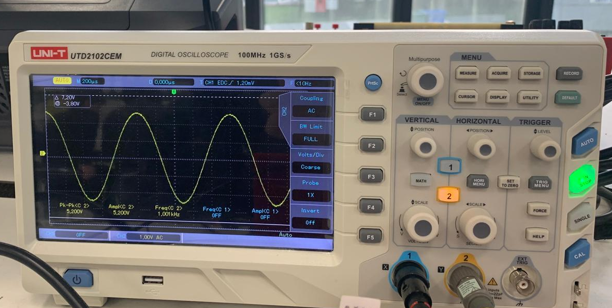
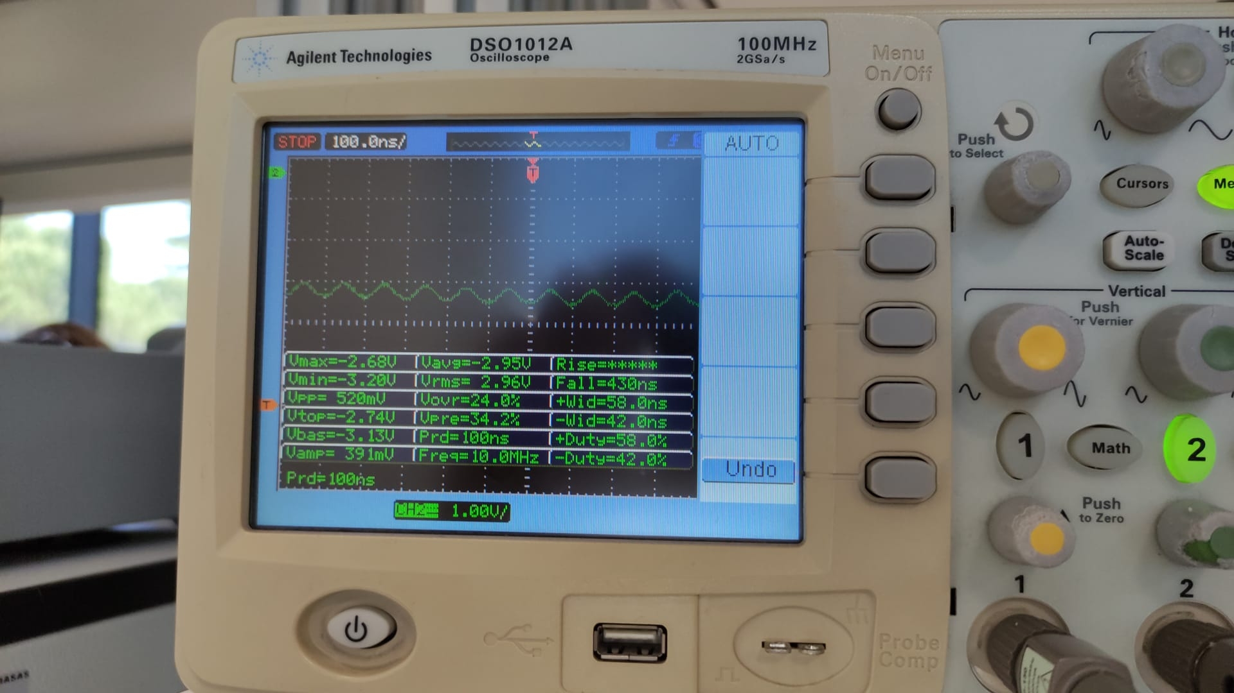

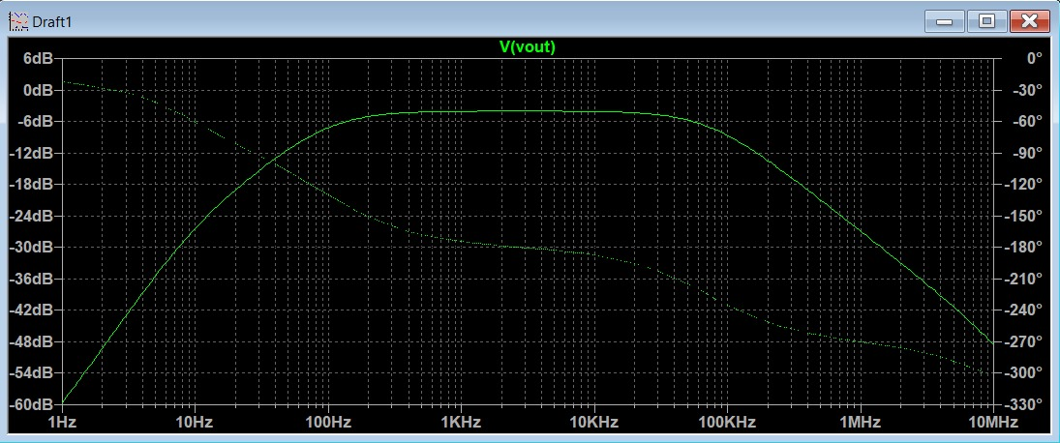

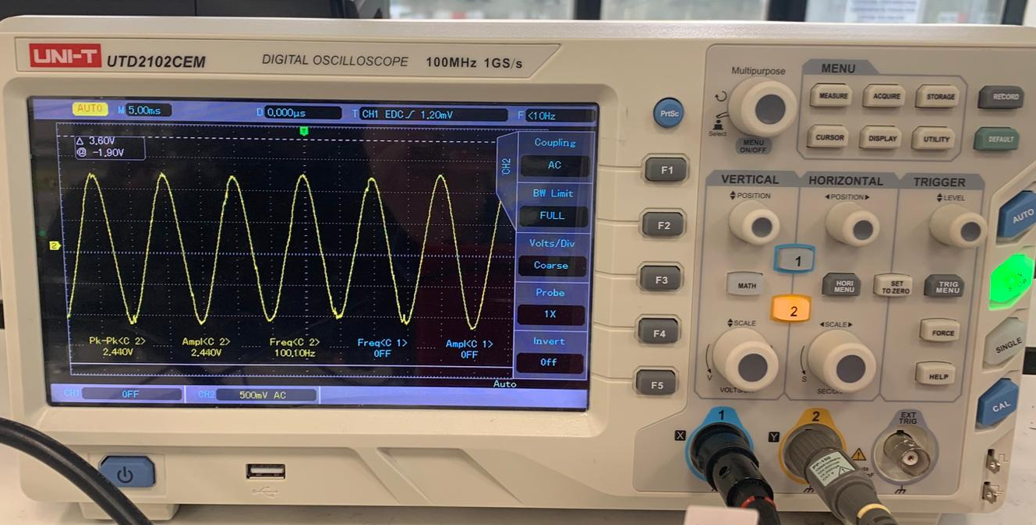
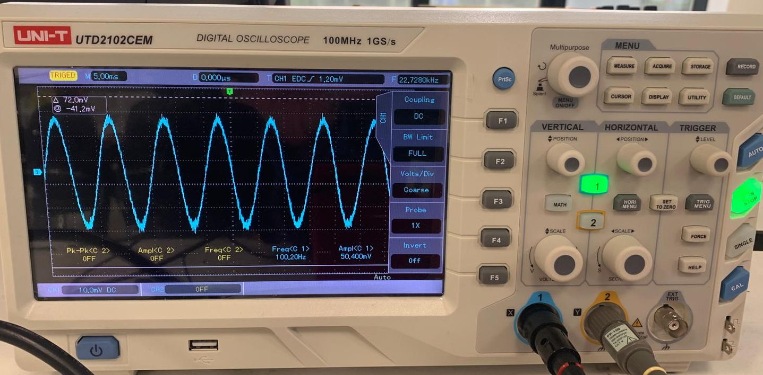
- Power down and disassemble the circuit.
- Set-up the circuit in Fig. 2. Be very careful while connecting the capacitor. The +/- pins must be connected as shown in the Fig. 2.
- Connect the ground and then Vee and Vcc. Power up your circuit.
- Apply sine waves of 10Hz, 100Hz, 1kHz, 10kHz, 100kHz, 1MHz, 10MHz with amplitudes of 50mV to Vin.
- Also find the 3-dB cut-off frequencies.
- Plot the gain in dB as a function of the frequency. Indicate the low (f_{L}) and high (f_{H}) cut-off frequencies. Hard to find cut-off frequencies because of derivation

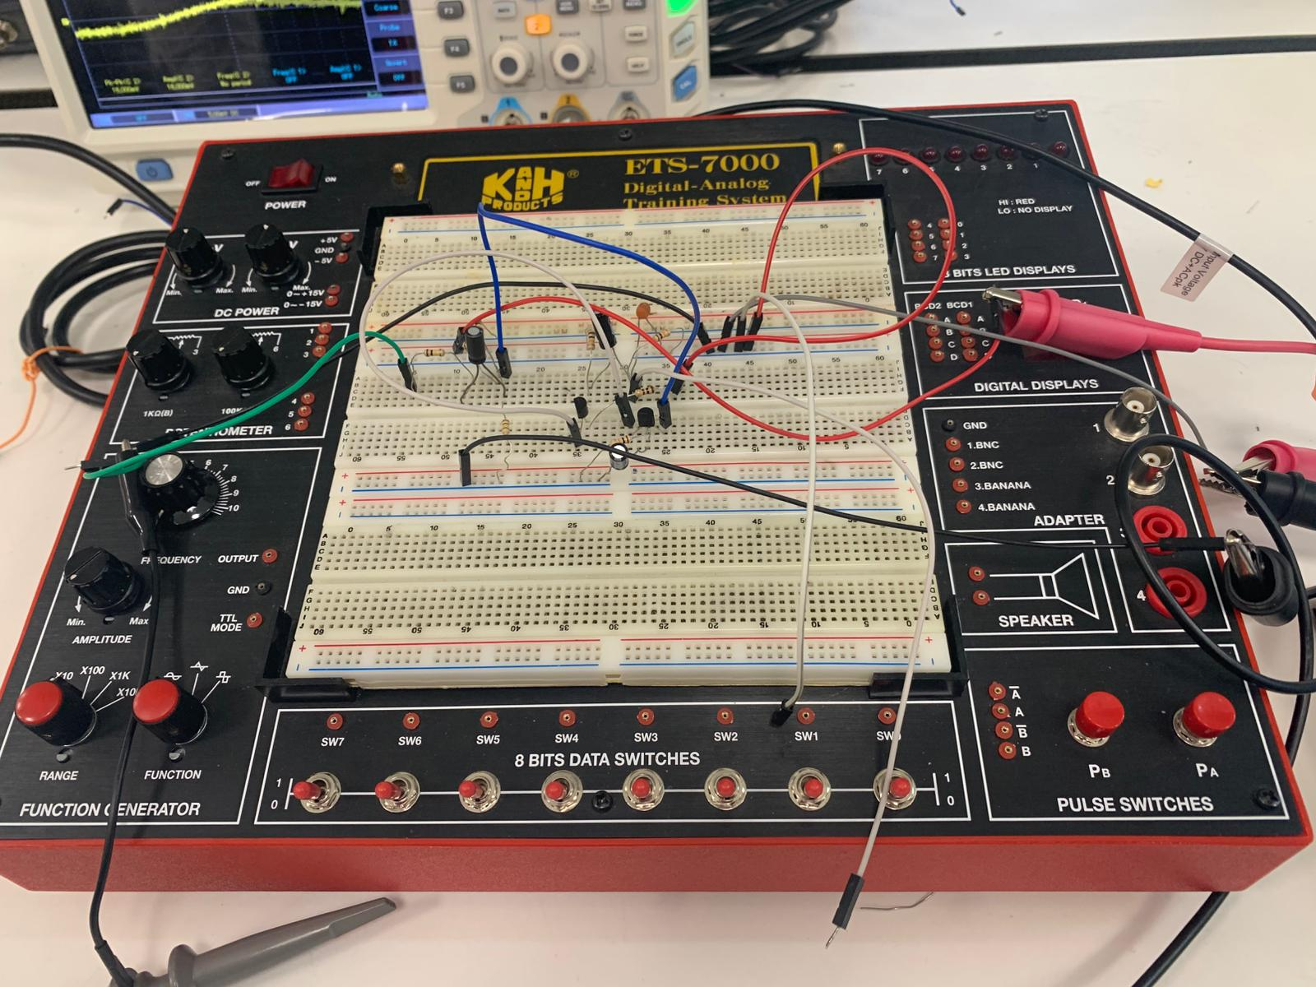
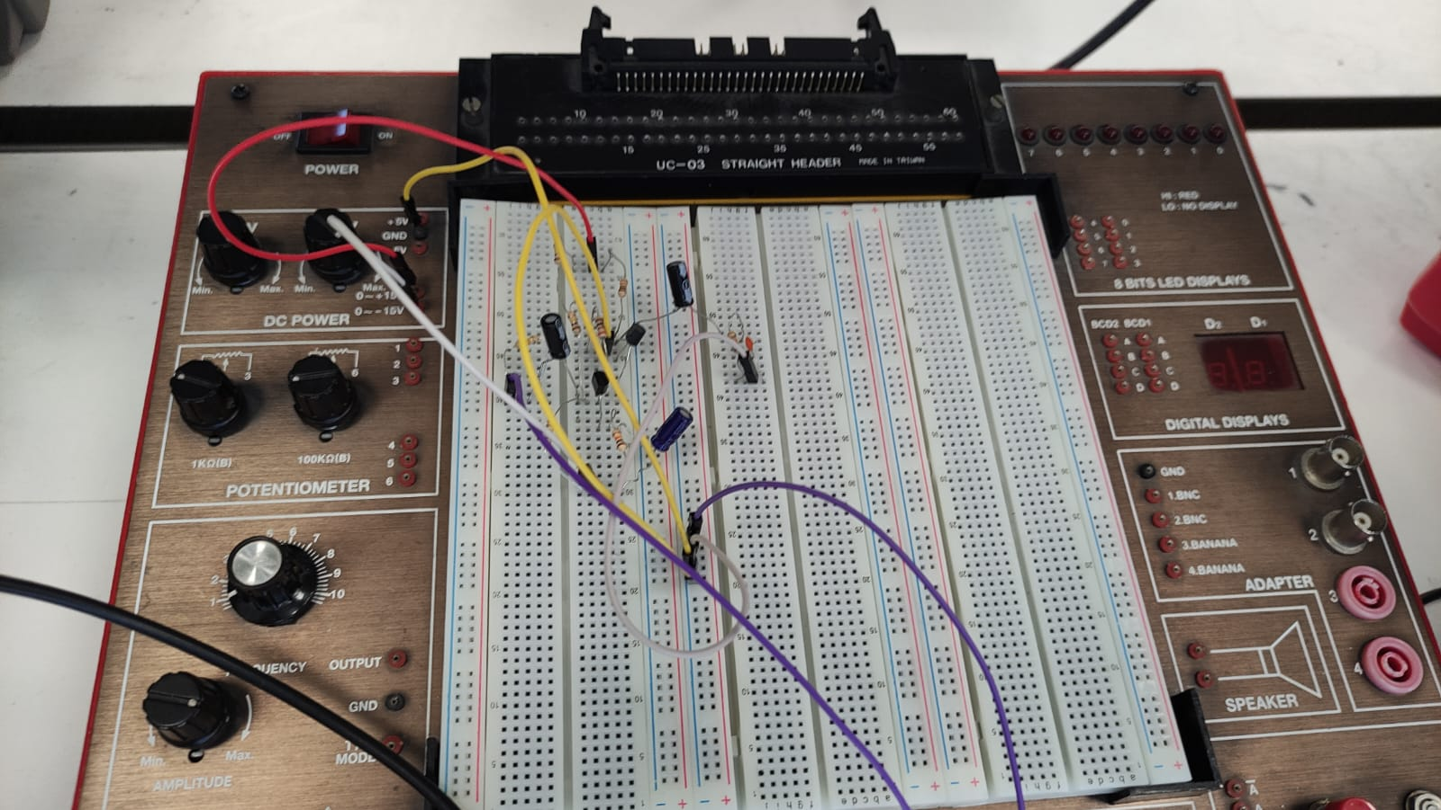
2.Devre

10Hz
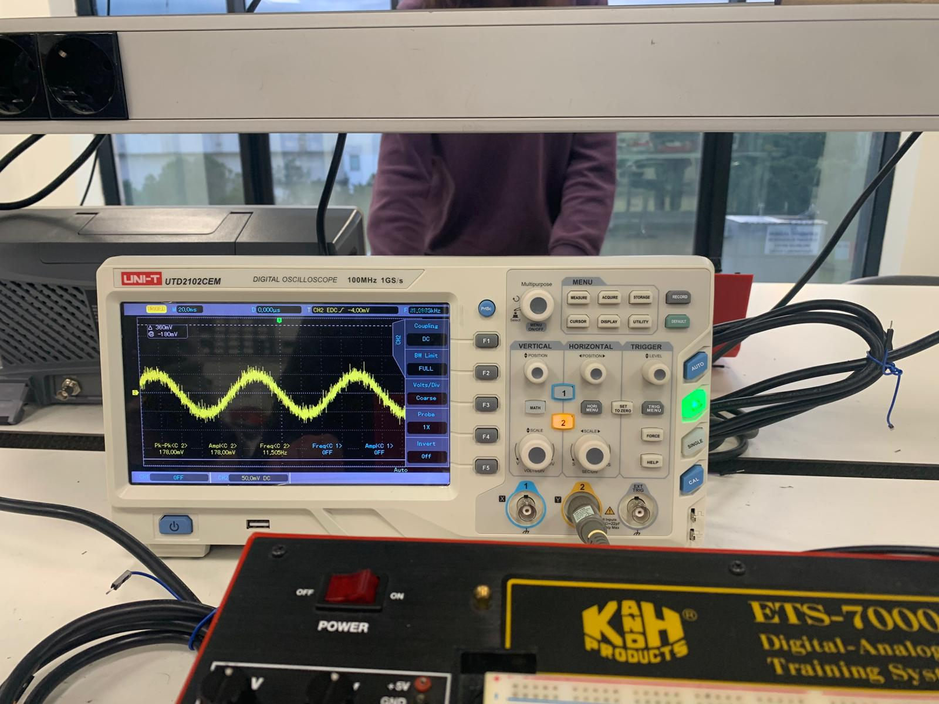
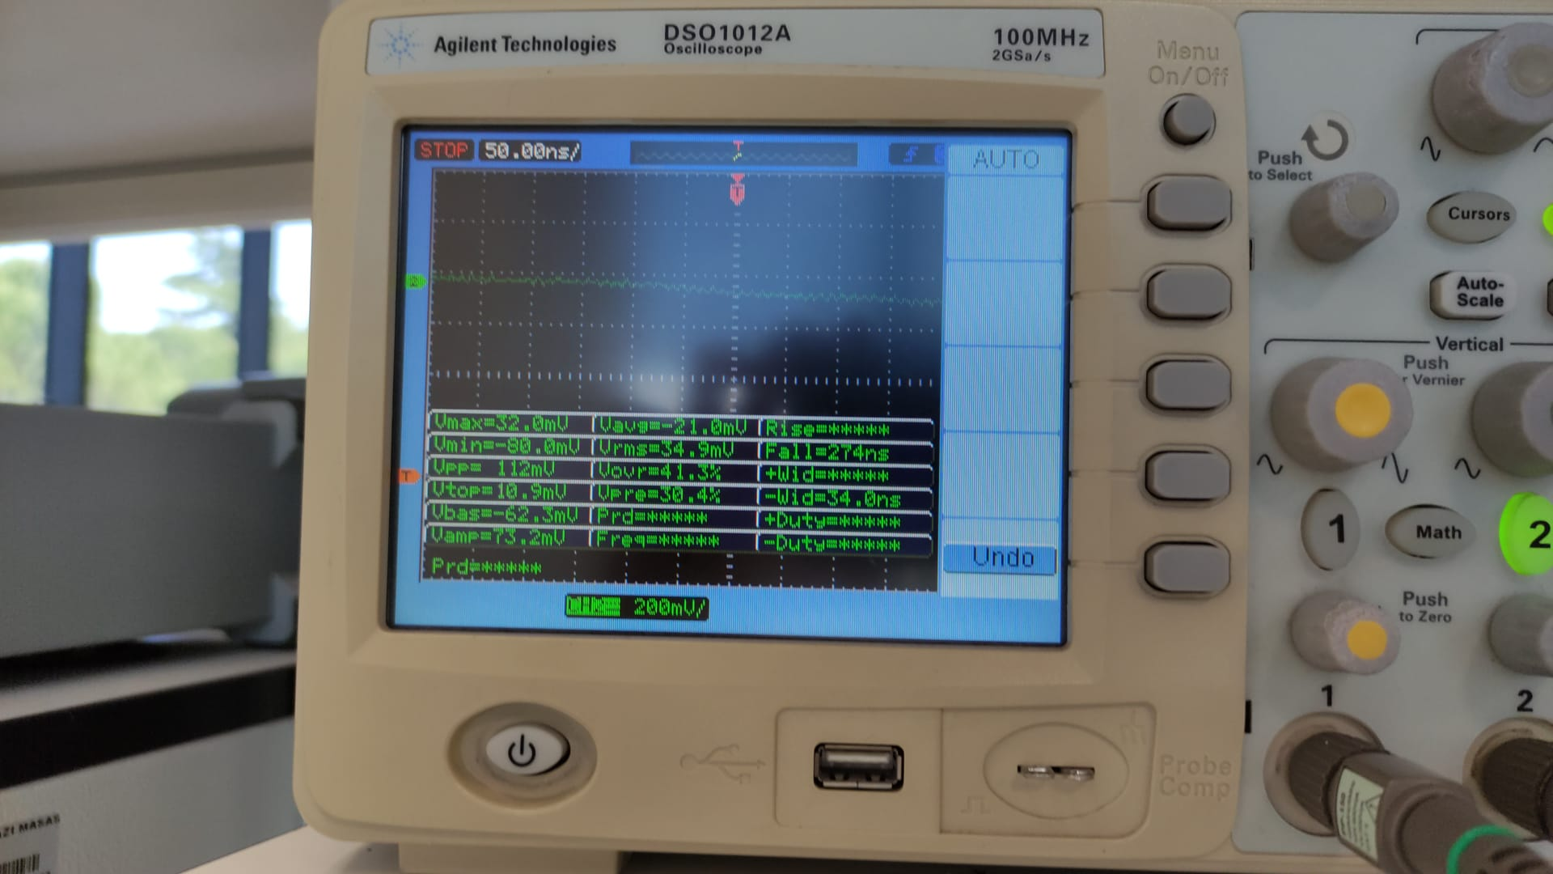

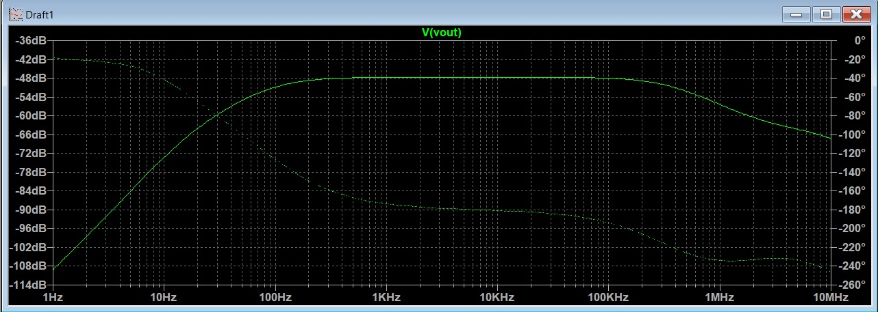

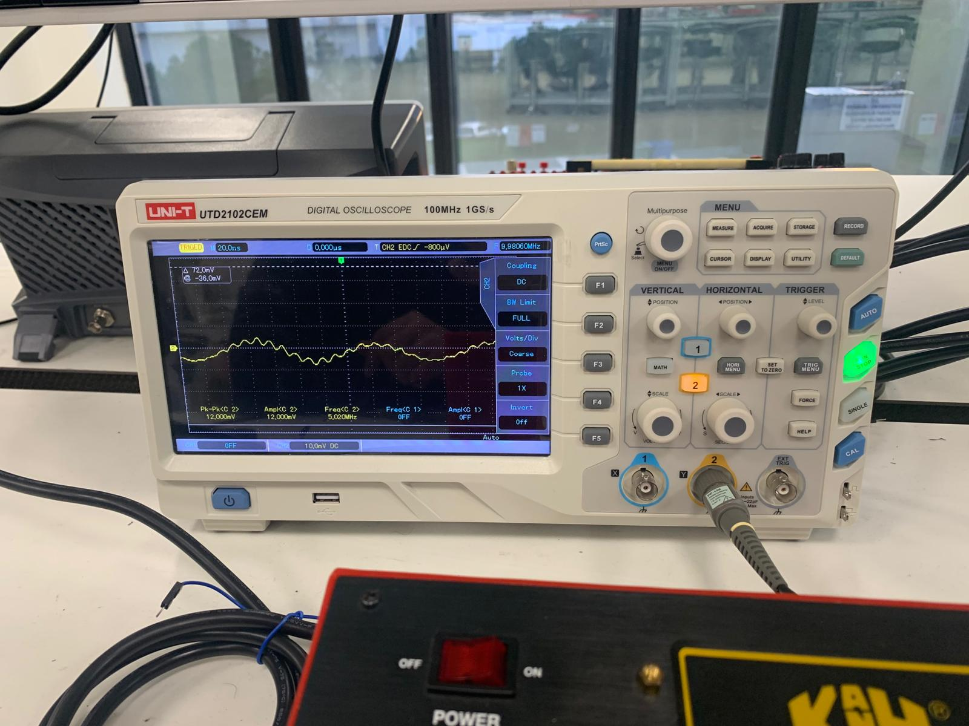
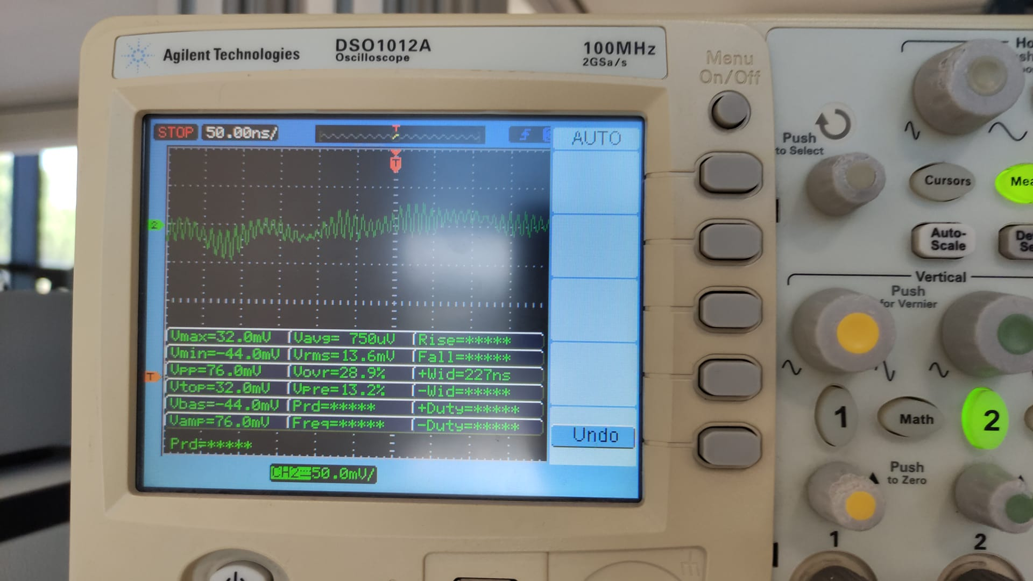
100 Hz

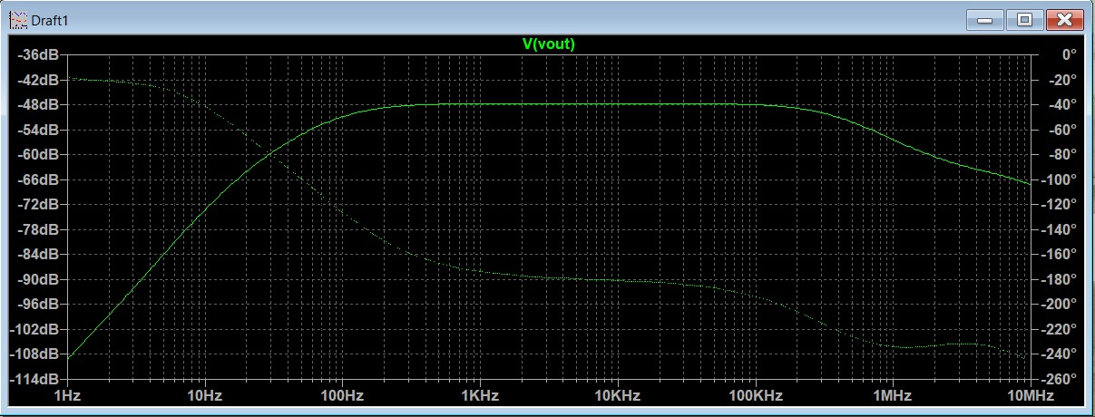

1k Hz
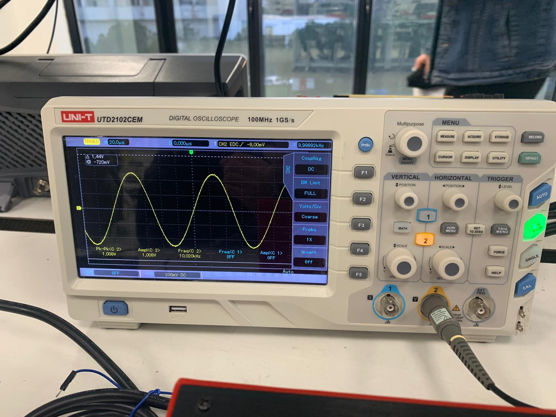
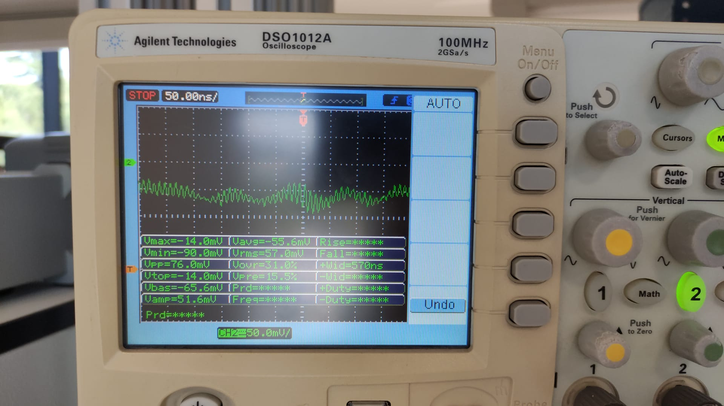

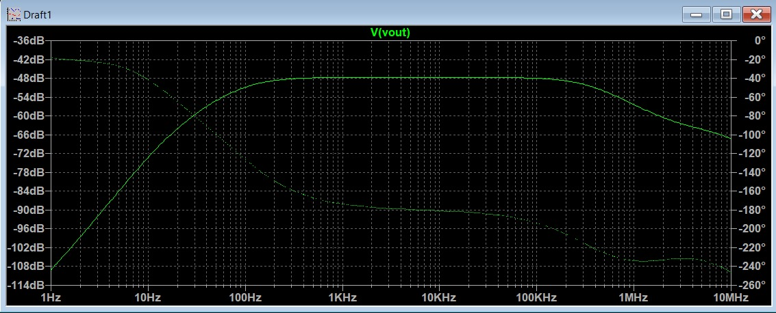

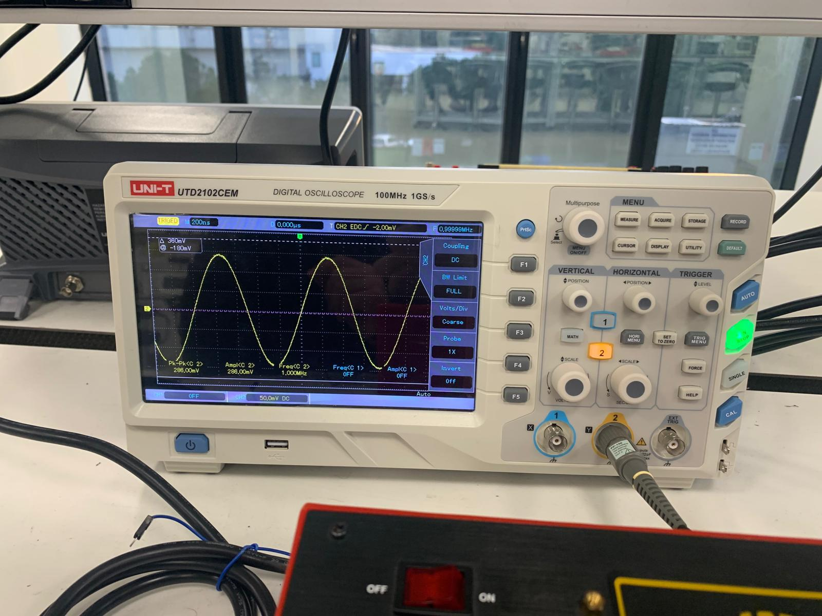
10k Hz
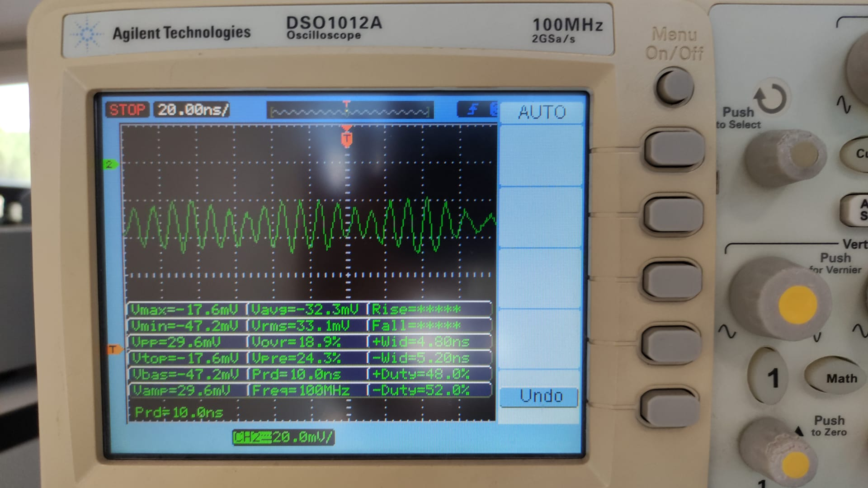

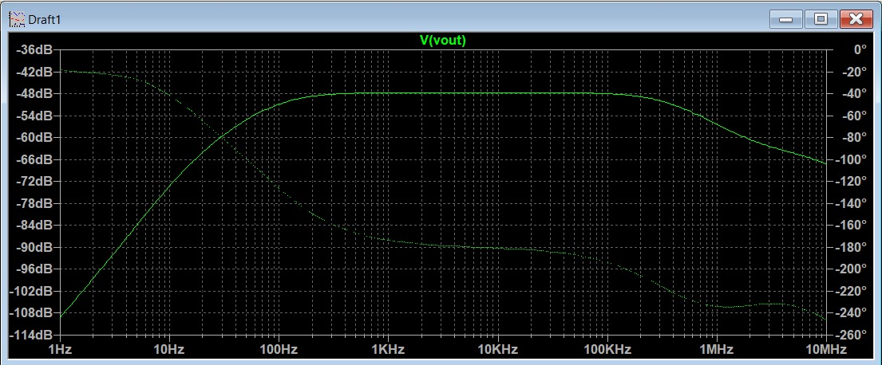

100k Hz
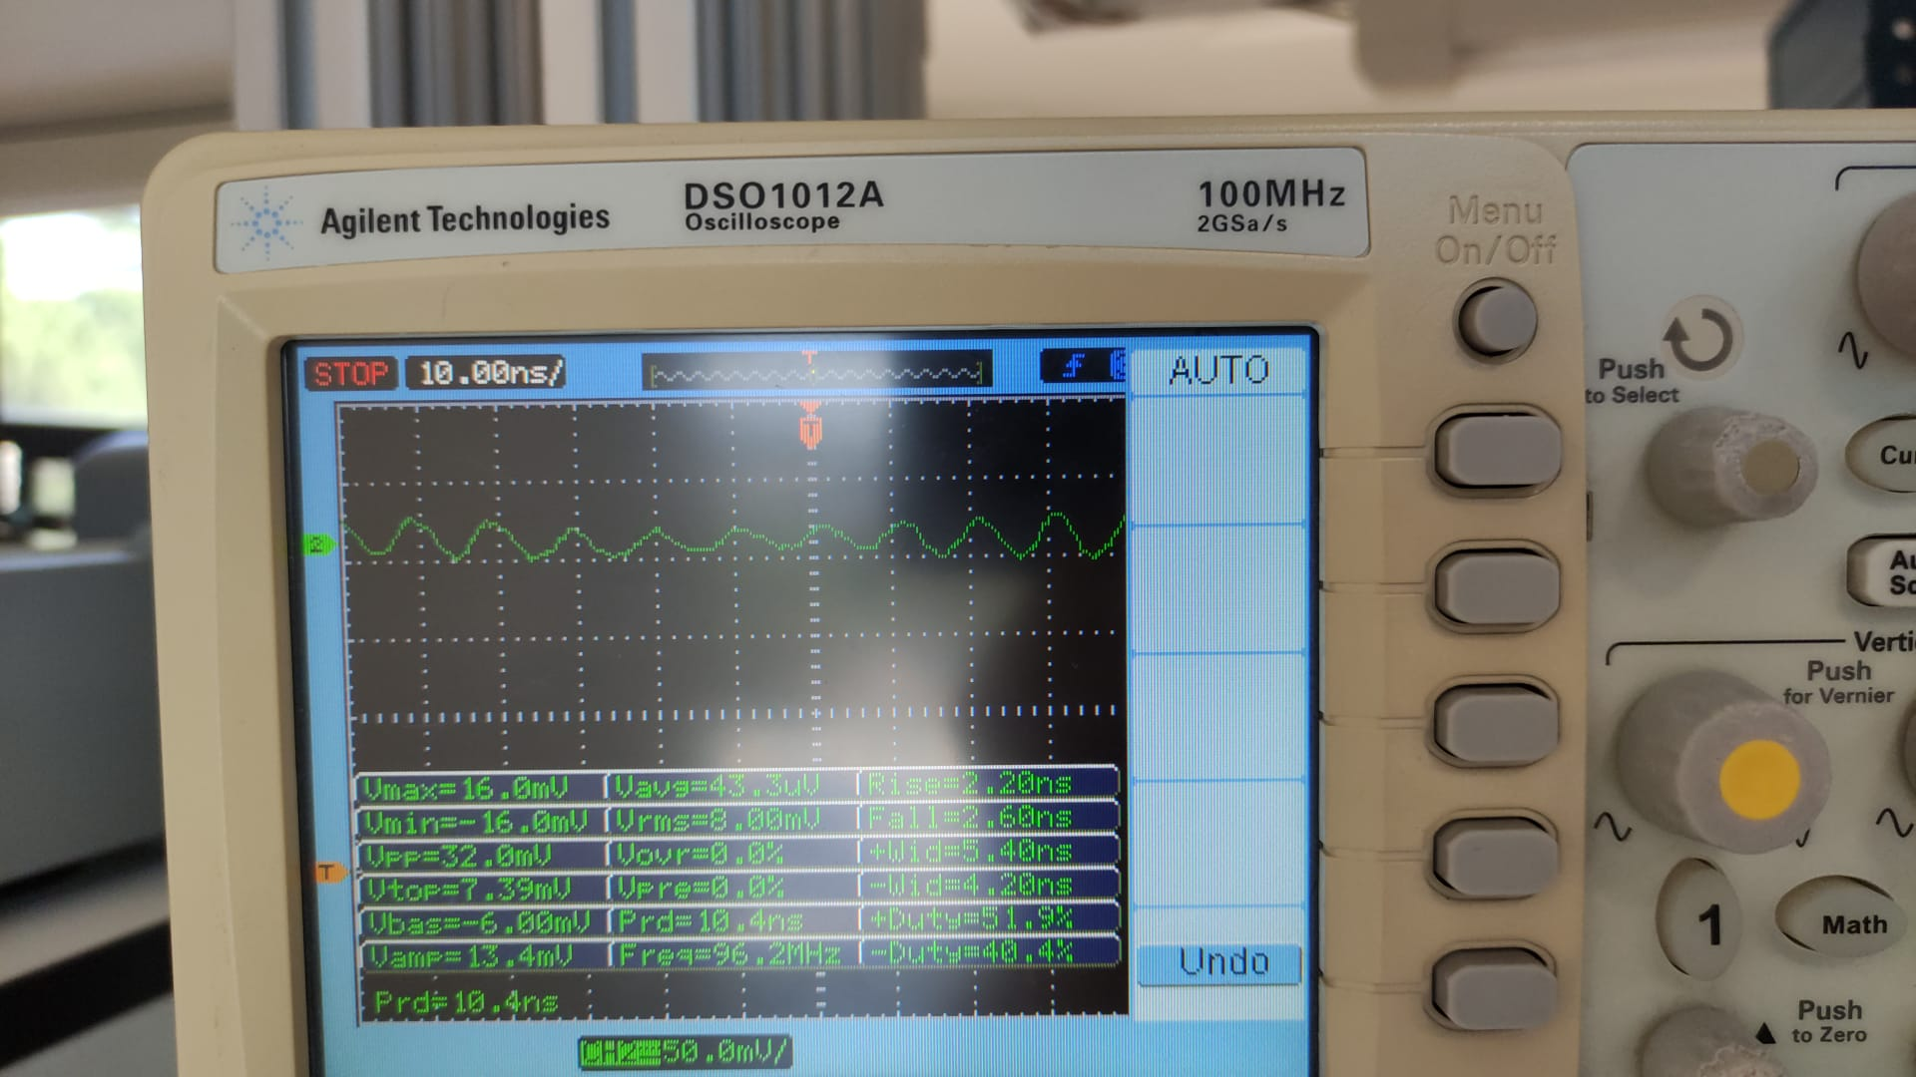

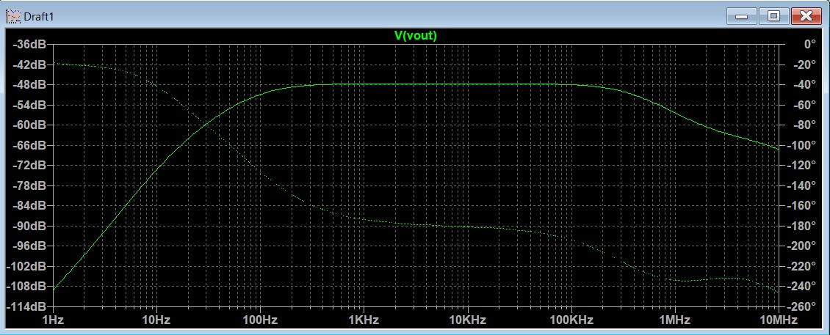

1M Hz
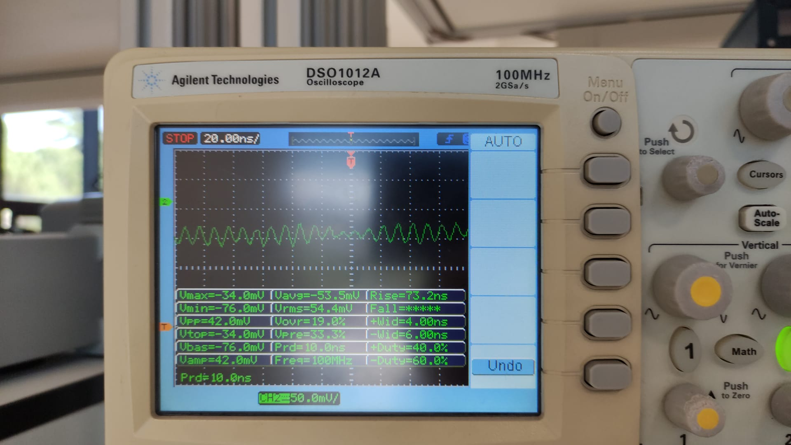

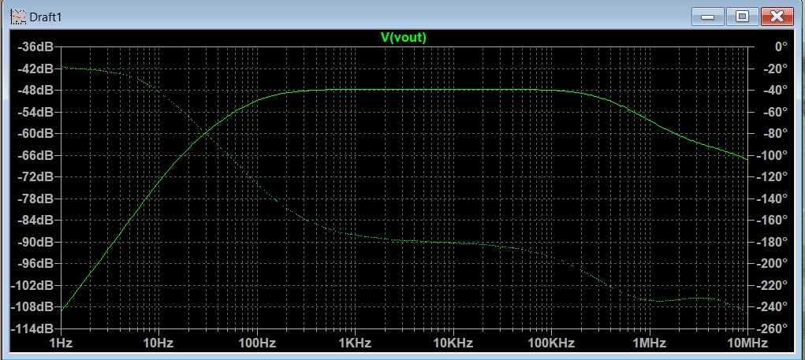

10M Hz
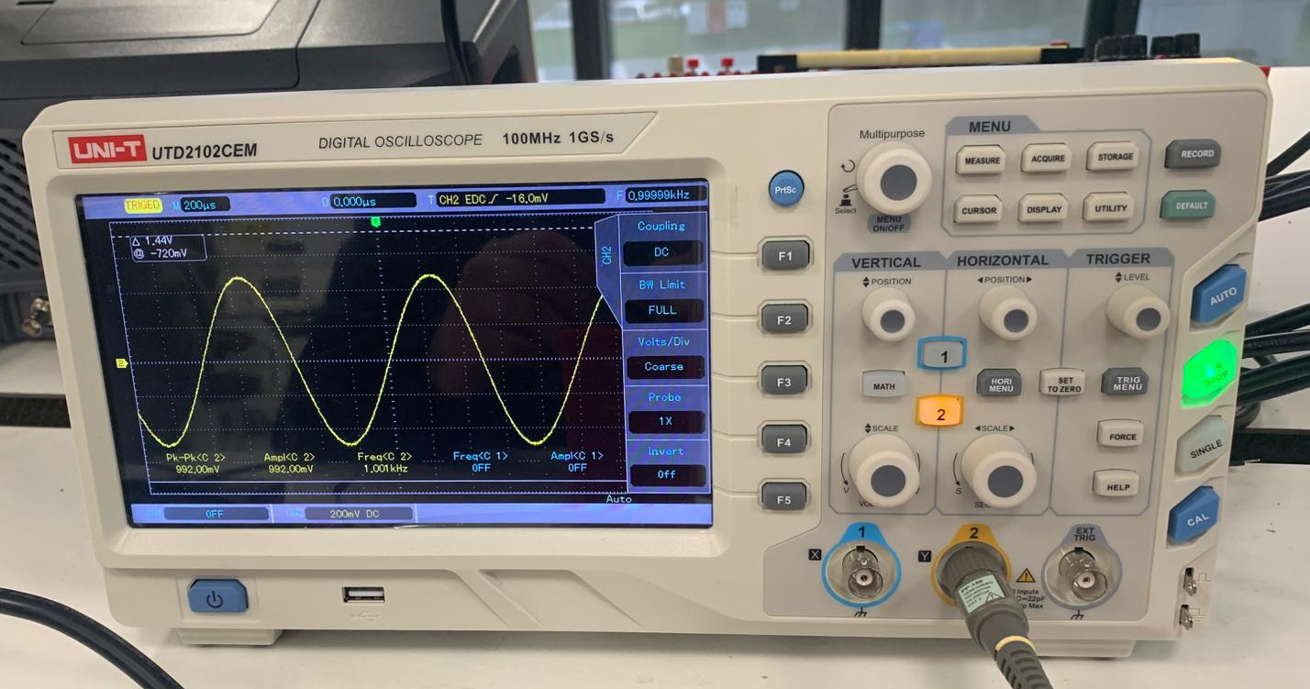
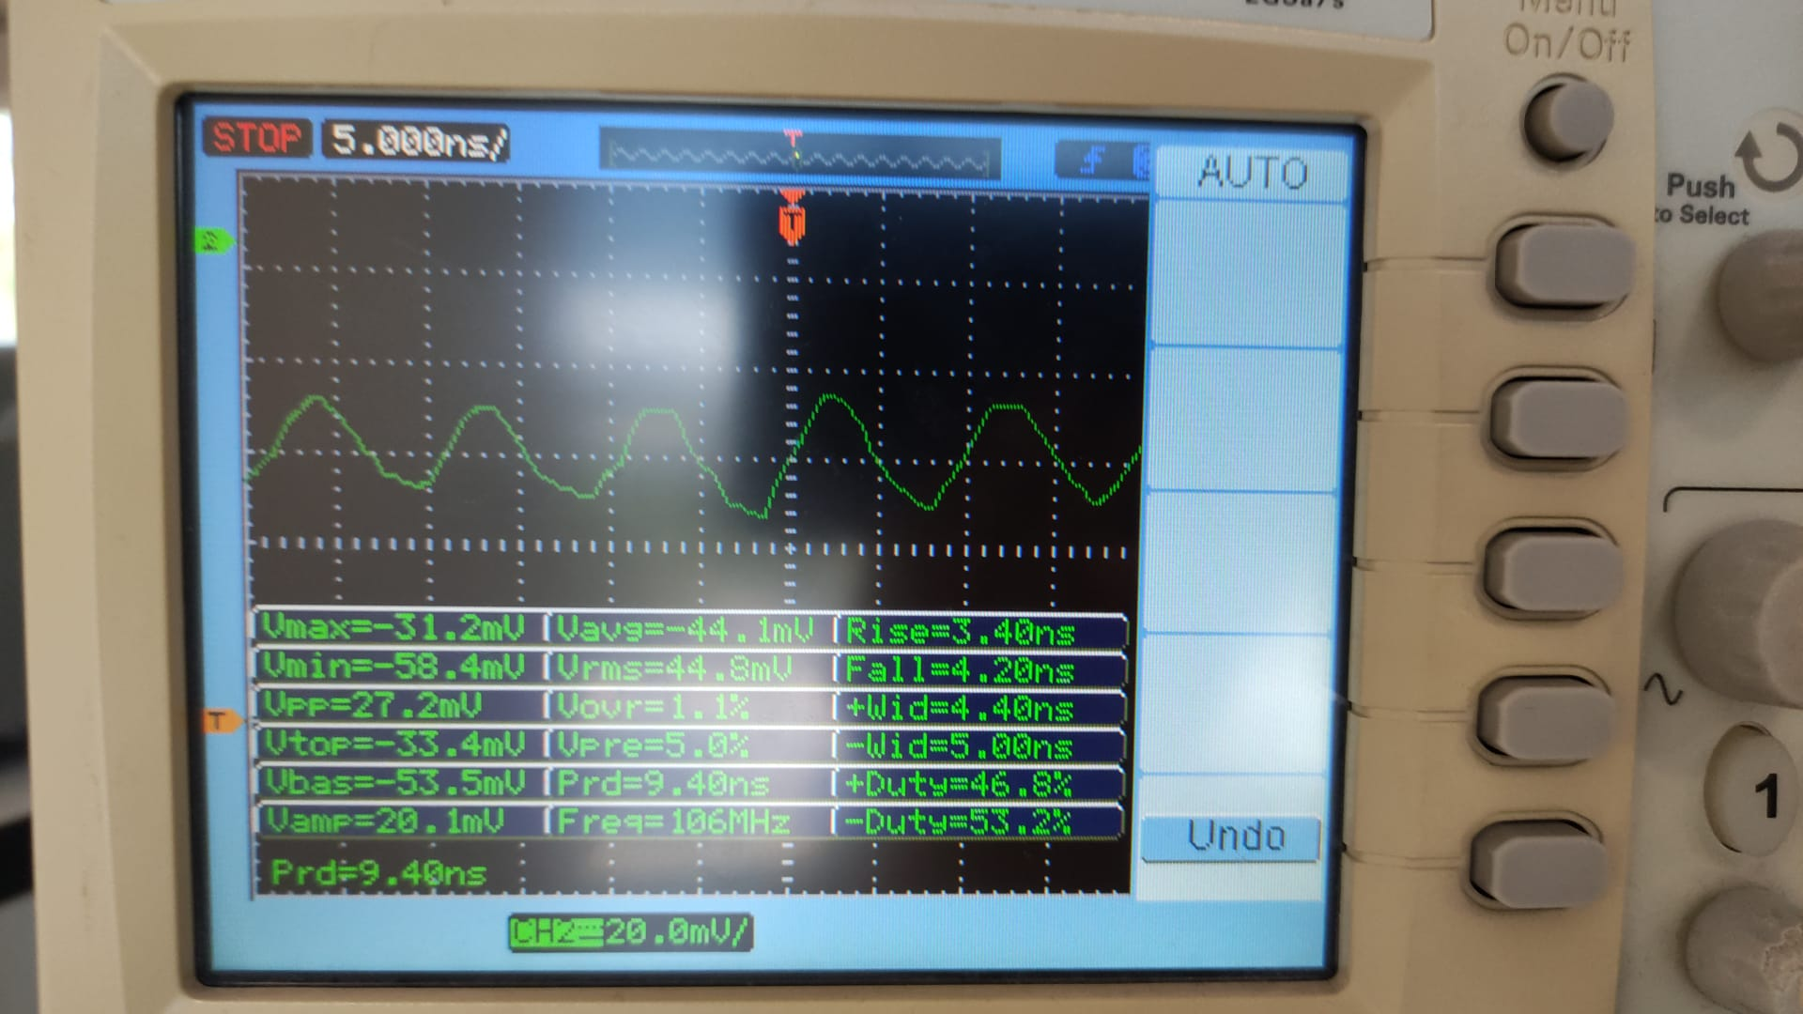

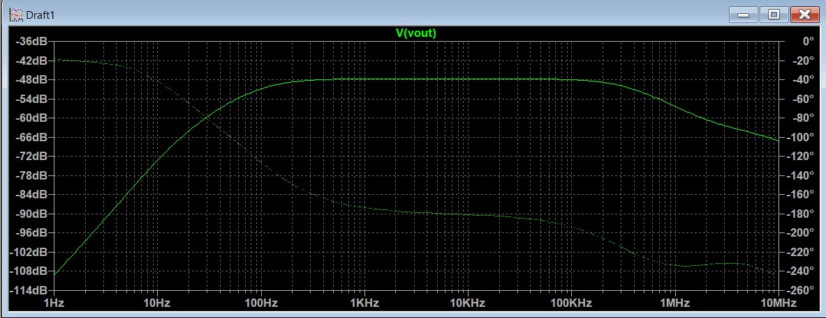

19. Compare the calculated (step 1, 3), simulated (step 2, 4) and measured (step 10, 16) responses.

Answer:
Our values which we measure on ltspice and the values was measure on lab are
close but our measured values in lab are a little bit different from others. We built our both two circuits correctly and measure the values and We didnt think we have a trouble with ltspice. Because of our calculations and simulation measurements are close, we think maybe we had a mistake when we were measuring in labratory. Maybe it is about the cables, breadbords or ac source.

